**Central limit theorem (CLT)**

The [central limit theorem](https://www.scribbr.com/statistics/central-limit-theorem/) is the basis for how normal distributions work in statistics. In probability theory, the central limit theorem (CLT) states that the [distribution of a sample](https://www.investopedia.com/terms/s/sampling-distribution.asp) variable approximates a normal distribution (i.e., a “bell curve”) as the sample size becomes larger, assuming that all samples are identical in size, and regardless of the population's actual distribution shape.

Mathematically, the Central Limit Theorem can be expressed as follows for the sample mean:

If X1, X2, ..., Xn are independent and identically distributed random variables with mean μ and standard deviation σ, and if n is sufficiently large, then the sampling distribution of the sample mean is approximately normally distributed with mean μ and standard deviation σ/√n.

Key points about the Central Limit Theorem:

1. **Independence:** The random variables being summed or averaged must be independent of each other. Independence means that the outcome of one random variable does not affect the outcome of another.
2. **Identically Distributed:** The random variables should be drawn from the same probability distribution, and they should have the same mean (μ) and standard deviation (σ).
3. **Sample Size:** As the sample size (n) increases, the sampling distribution of the sample mean or sum approaches a normal distribution, even if the original population distribution is not normal.
4. **Approximation to Normality:** The larger the sample size, the closer the sampling distribution resembles a normal distribution, regardless of the shape of the original population distribution.

Sample sizes equal to or greater than 30 are often considered sufficient for the CLT to hold.

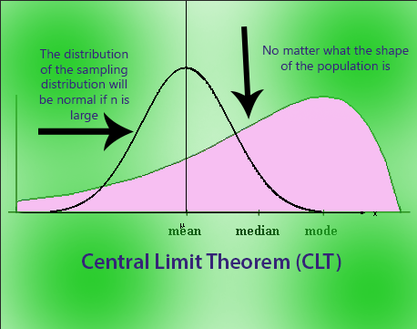

In our context,

If the number of samples taken in our project is greater than 30, we consider the data to be normally distributed by applying central limit theorem. For example, the price of instant food items taken are considered to be normally distributed if the sample size is greater than 30.

Video link: [central limit theorem](https://youtu.be/YAlJCEDH2uY?si=5WoY0QswlQ1Tcm_v)